Updating Your Apple Account
User Guide

What's Happening?
To better separate work and personal accounts, your organization has determined that personal Apple Accounts can no longer use a work email address. If you use your work email for your personal Apple Account, you'll need to change it to a personal email address (such as @gmail.com or @outlook.com).
You'll receive an email from Apple and a notification on your Apple devices. Depending on your language settings, the email and notifications may be in English, Dutch, or another configured language.
Depending on how you use your Apple Account, you may see one or two options:
- Keep as a Personal Account
- Transfer to a Work Account
Most users will only see the first option.

Keep as a Personal Account
Always Choose "Keep as a Personal Account"
Always choose the option to keep your existing Apple Account as a personal account and change the email address to your personal email. This preserves all your personal purchases, apps, and iCloud data. Most users will only see this first option.
You simply change your email address to a personal one and your account remains fully yours.
What if I see two options?
Some users may see a second option. Always choose "Keep as a Personal Account."

Transfer to a Work Account
Warning: this option has significant limitations and CANNOT be undone!
With this option, your Apple Account is transferred to your organization. The organization gains full control over the account and associated data.
Limitations of a Work Account
When your account is converted to a work account, the following limitations apply:
- iCloud: Limited or no access to iCloud storage and services
- App Store: Potentially limited access to apps, depending on organization policy
- Find My / Health: Not available
- Purchased apps: Remain available and can be updated
- Subscriptions: Existing subscriptions remain active but cannot be renewed
- Media content: Music, movies, TV shows, Fitness+, Apple TV+, Apple Arcade are no longer available
- Data access: The organization has access to data stored in iCloud
- Devices: You may need to use an organization-managed device

What You'll Need
The process takes about 5 minutes. You'll need:
- A personal email address (for example @gmail.com, @hotmail.com) that is not already used as an Apple Account
- Access to that email address to receive a verification code
- The passcode (PIN) for your iPad or iPhone

Step by Step

Step 1: You Receive an Email from Apple
You'll receive an email from Apple with the subject "Update your Apple Account." This email informs you that your account needs to be updated. If you have an iPhone, iPad, or Mac, you don't need to click "Get Started" in the email. We'll do this through Settings.

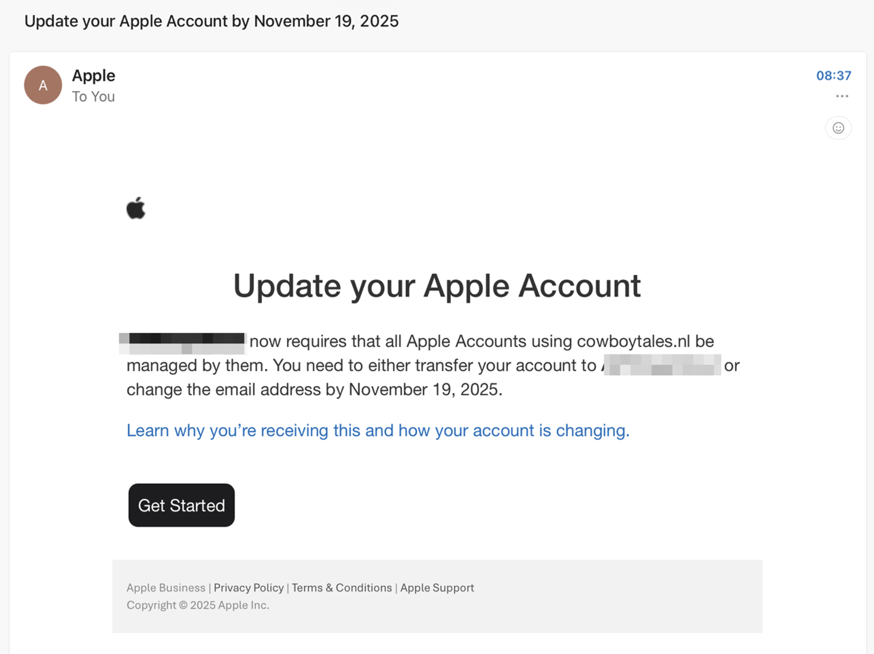

Step 2: Open Settings on Your Device
You'll see a red notification badge next to your Apple Account in the Settings app. This indicates that action is needed. Tap your name at the top left to continue.
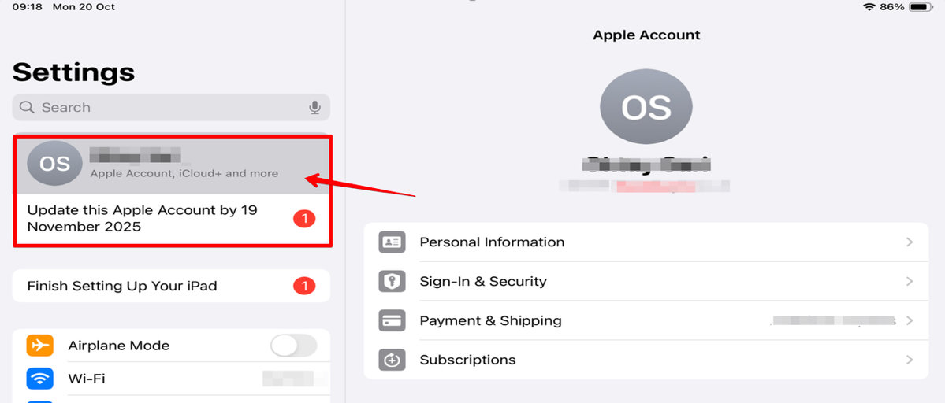

Step 3: Choose "Keep as a Personal Account"
IMPORTANT: Always choose "Keep as a Personal Account". With this option, you retain full control over your account and all your personal data, purchases, and apps.
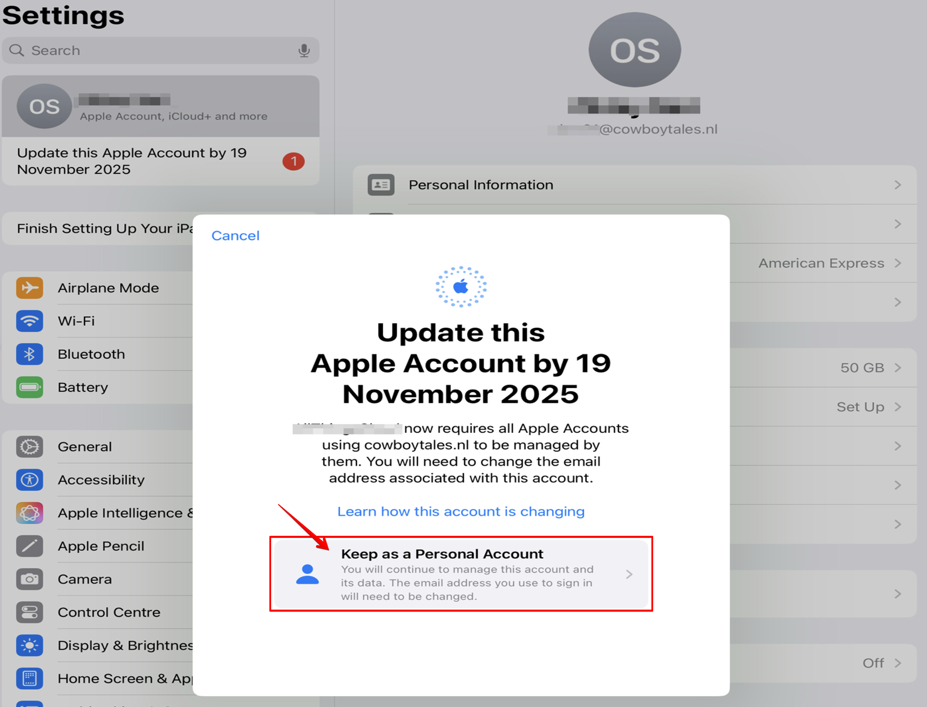

Step 4: Enter Your New Email Address
Enter your personal email address. This will become the new email address you use to sign in to Apple. Use an email address that is not from work, such as your personal Gmail, Hotmail, or Outlook address.
NOTE: The email address you enter here cannot already be associated with an existing Apple Account.
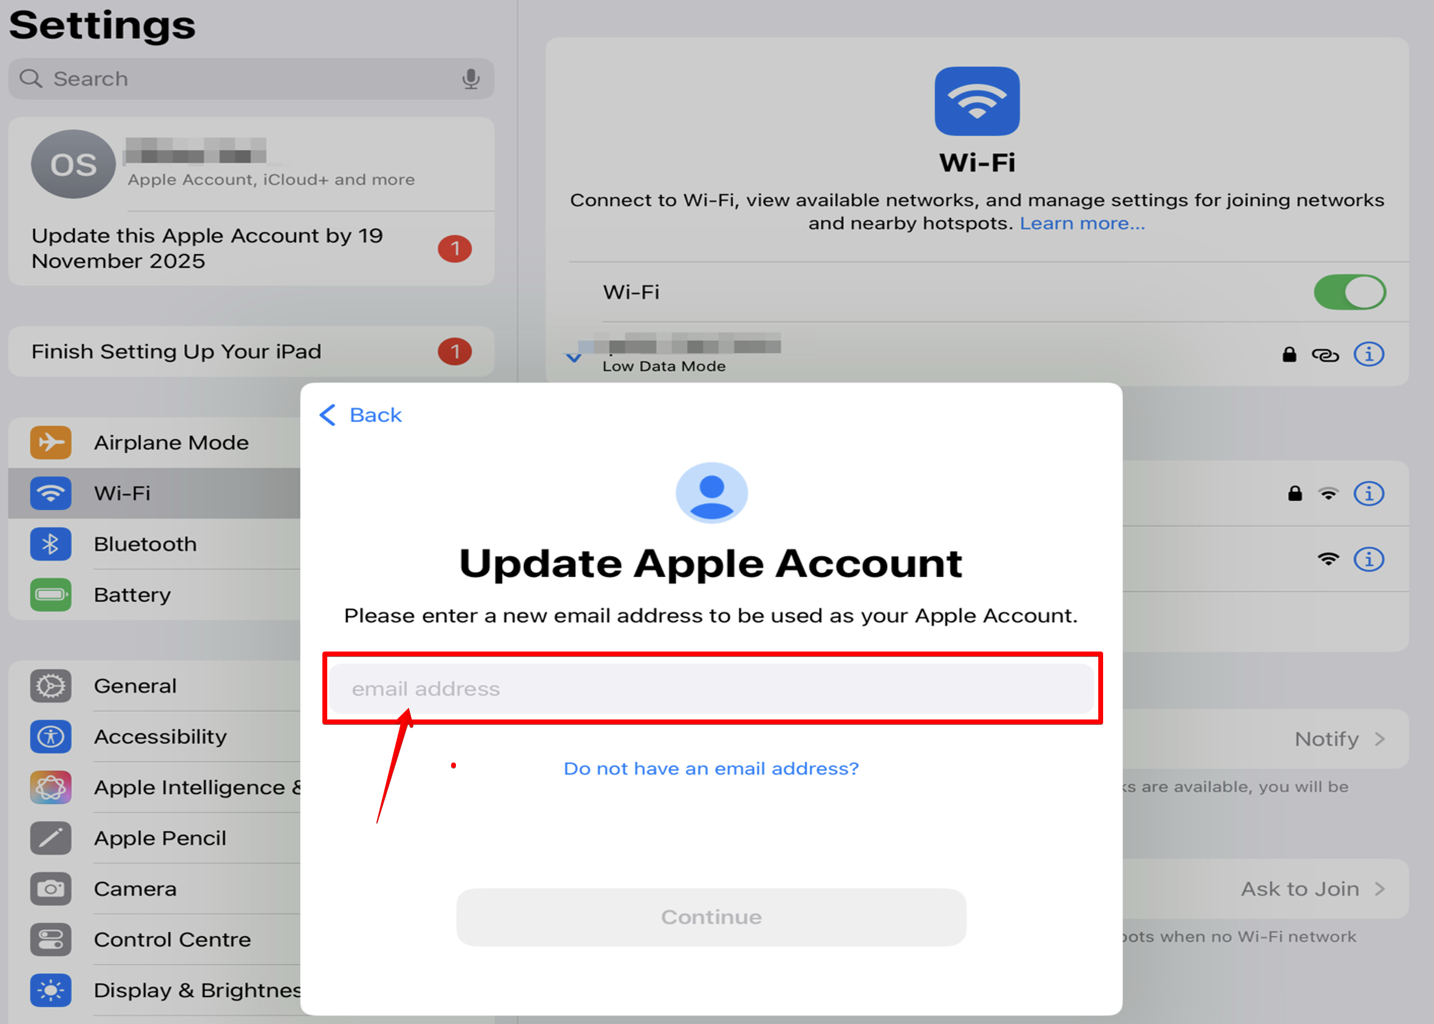

Step 5: Tap "Continue"
After entering your email address, tap the blue "Continue" button to proceed.
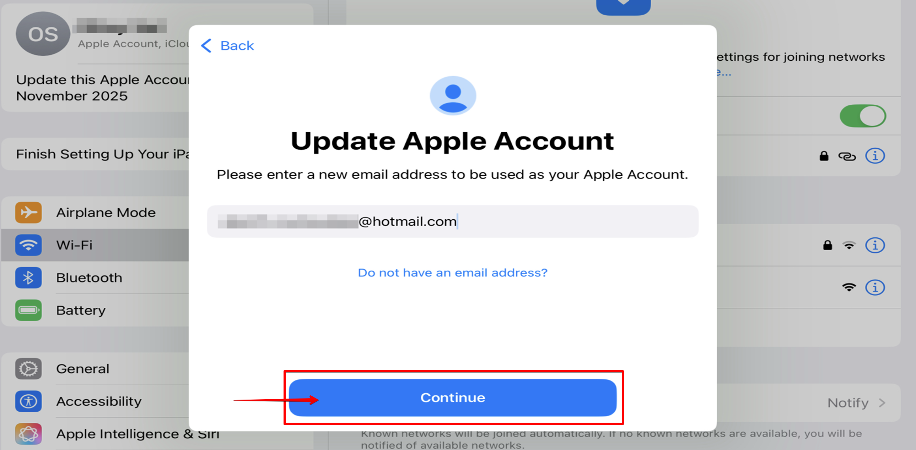

Step 6: Enter Your Device Passcode
For security, you'll be asked to enter your iPad or iPhone passcode. This is the same code you use to unlock your device.

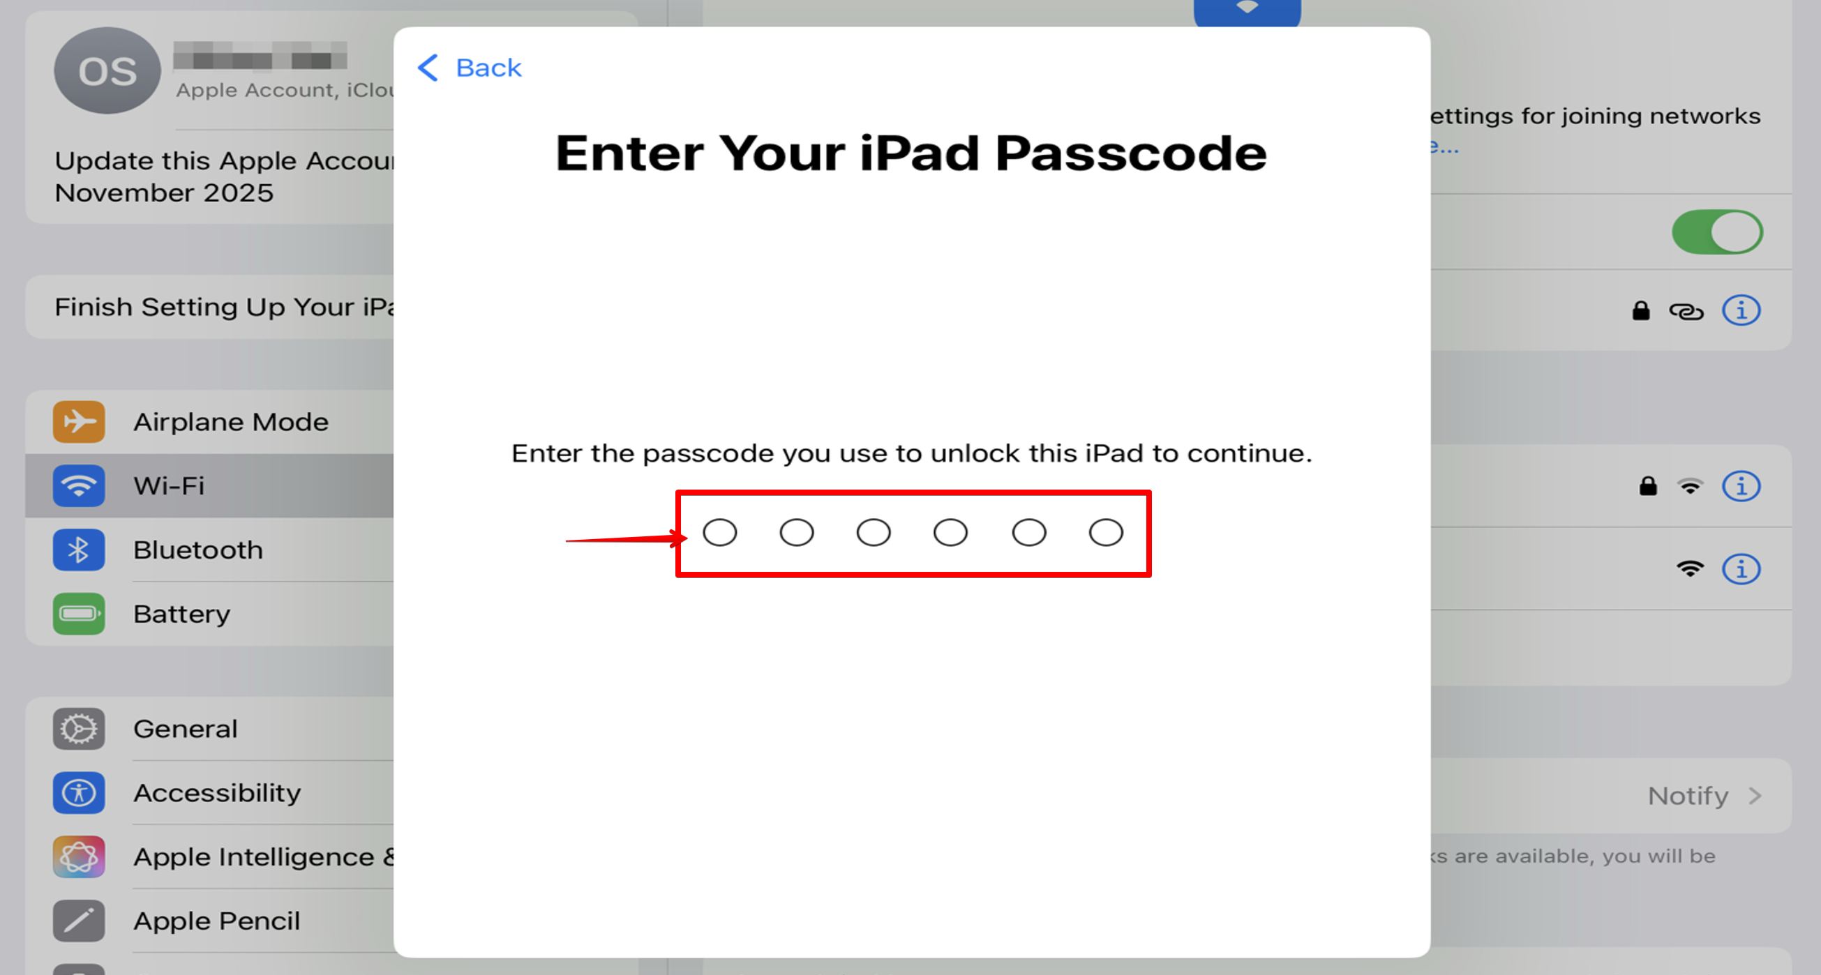

Step 7: Wait for Verification
Your passcode will be verified. This takes only a few seconds.
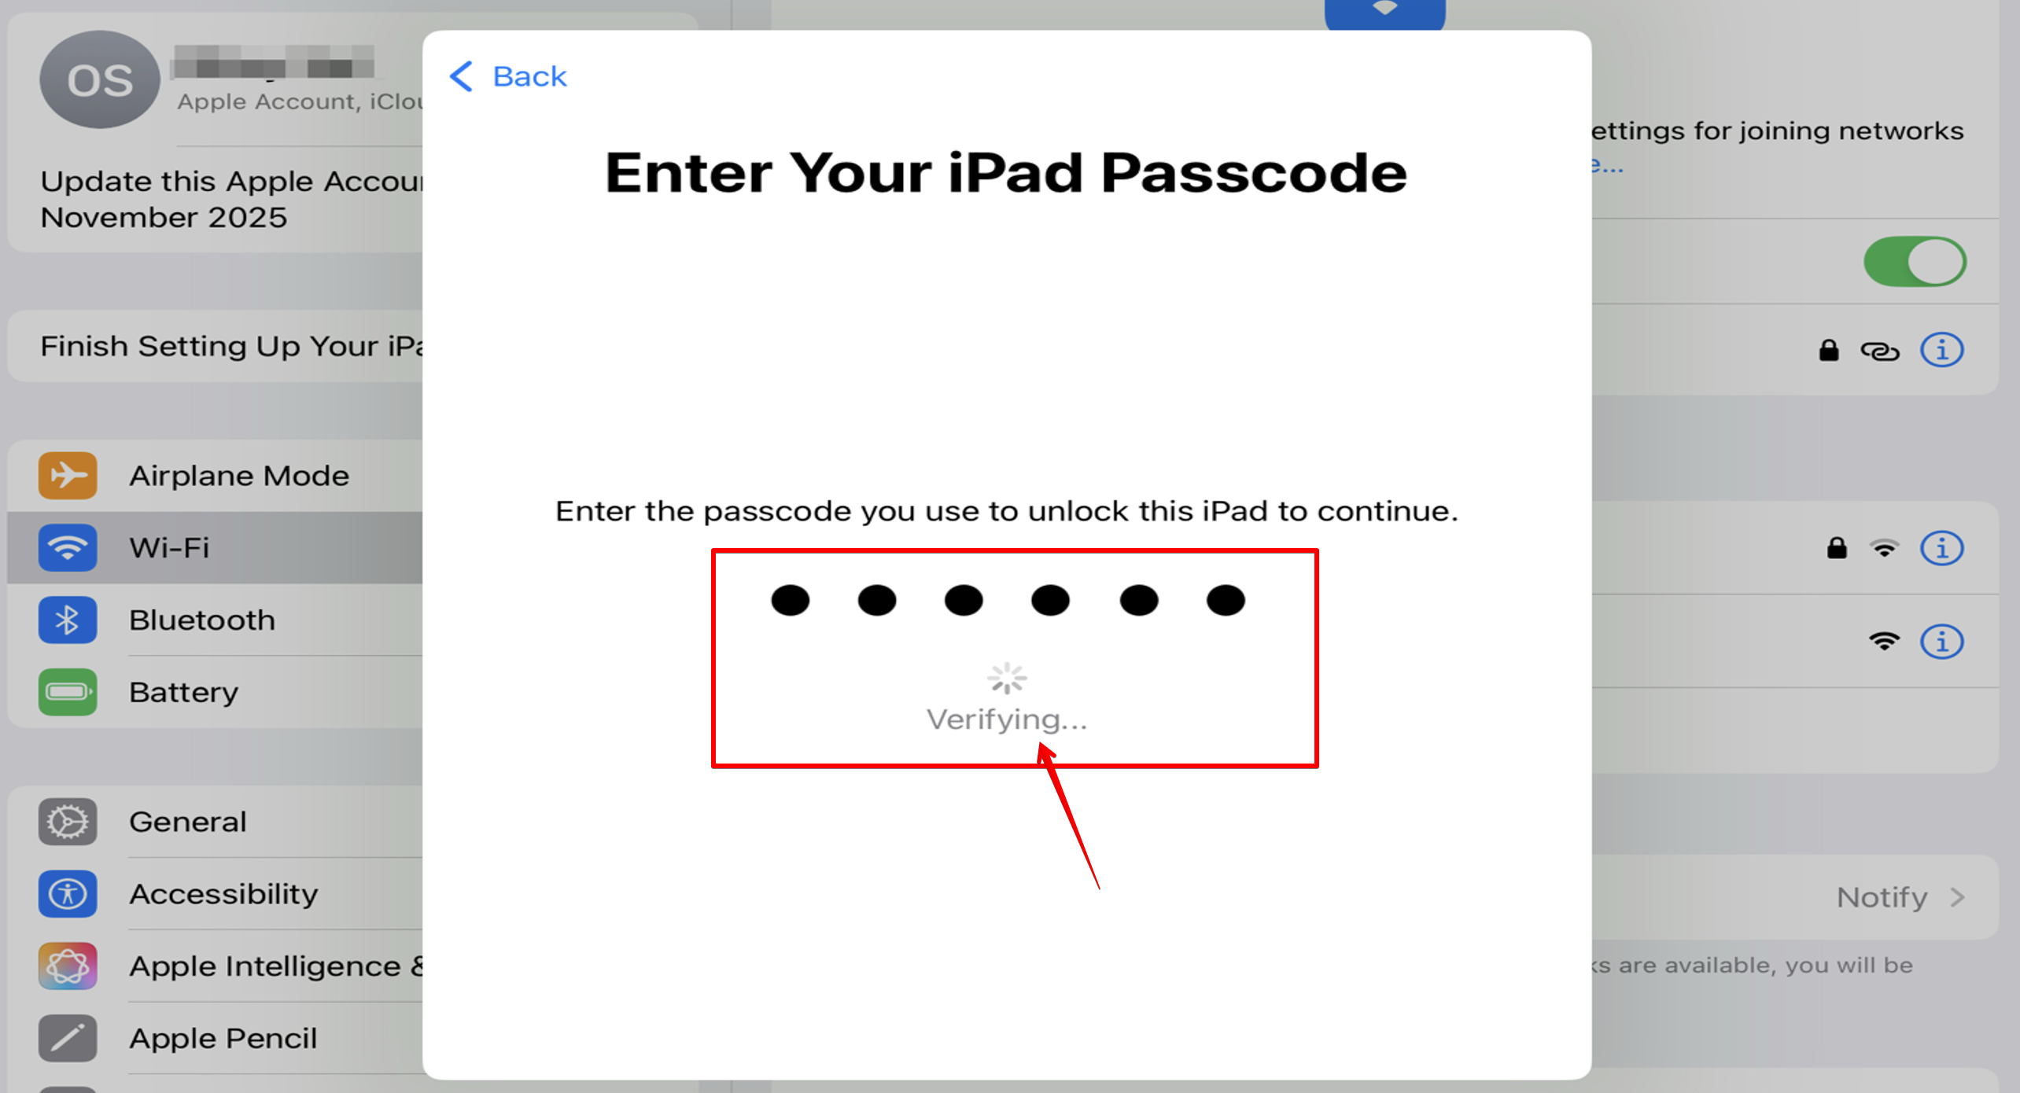

Step 8: Receive the Verification Code
Apple sends a verification code to your new personal email address. Open your email to view the code.

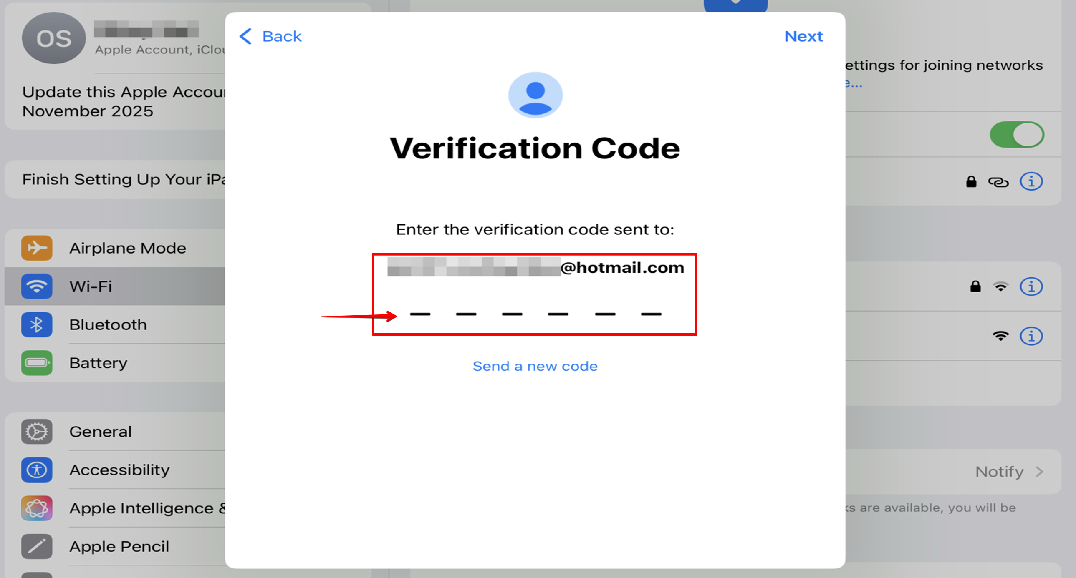

Step 9: Enter the Verification Code
Enter the 6-digit code you received by email. The code will be verified automatically.

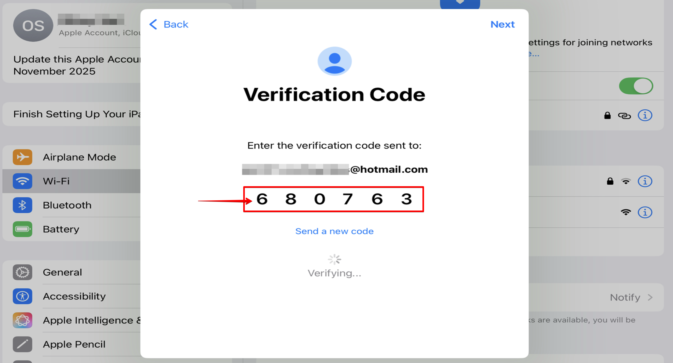

Step 10: Done! Your Account is Updated
You'll see a confirmation that your Apple Account has been updated. Tap "Done" to finish.
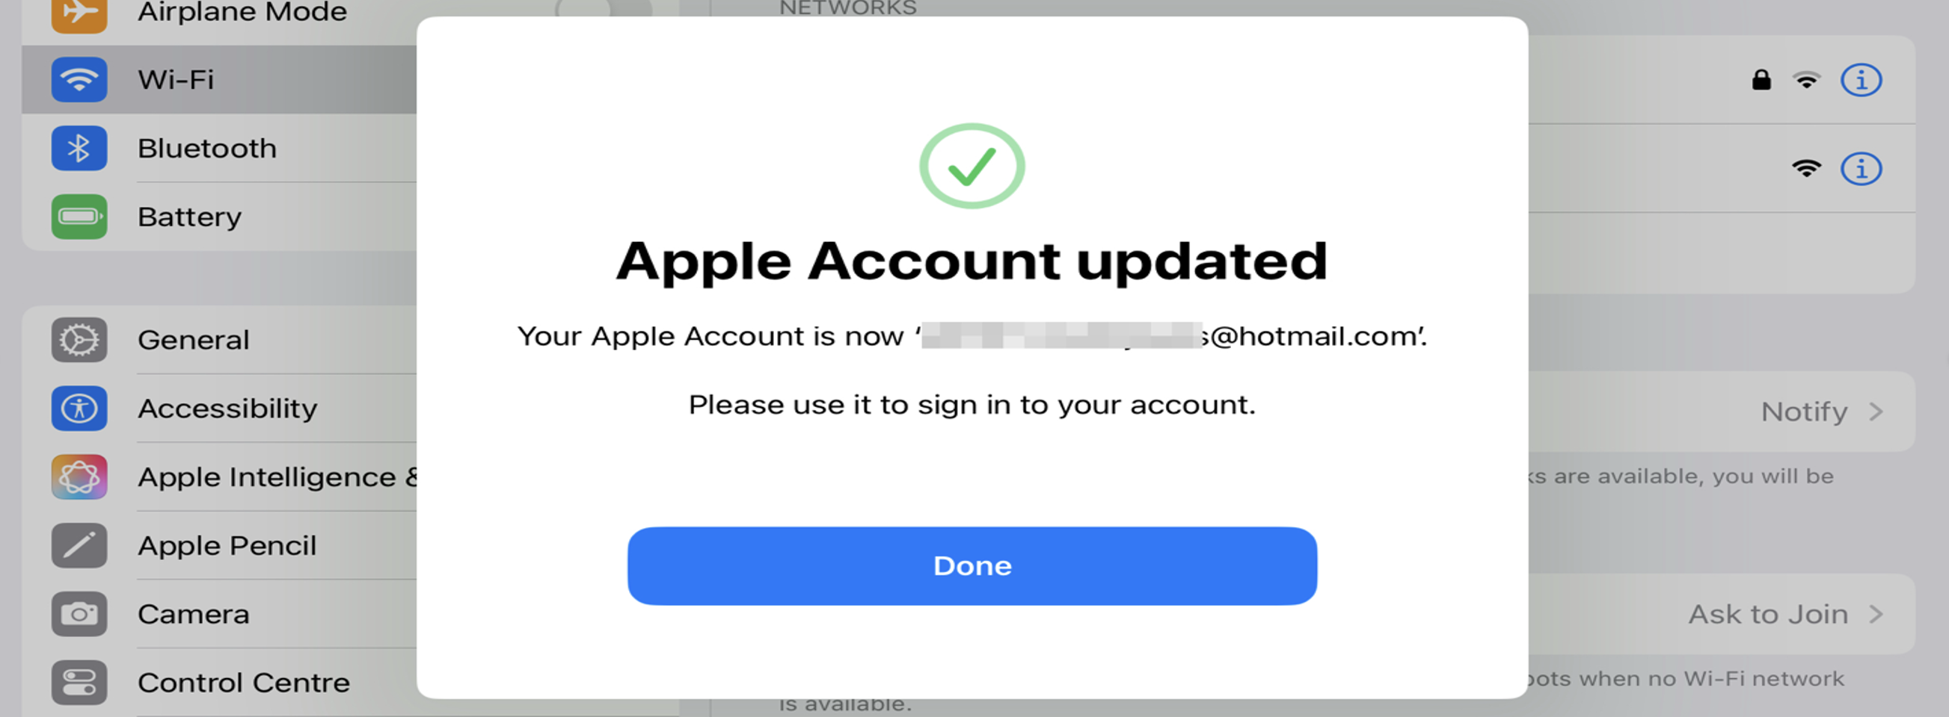

Step 11: Confirmation Email
You'll receive a confirmation email from Apple at your new email address. This confirms that the change was successful.

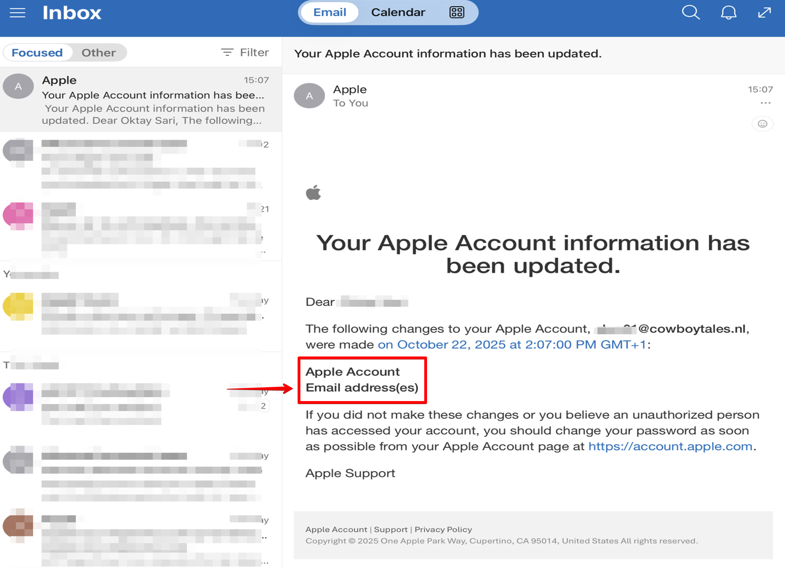

Result: Your Account is Now Personal
In Settings, you'll now see your new personal email address. The red notification badge is gone. Your Apple Account is now fully yours and no longer linked to the work domain.
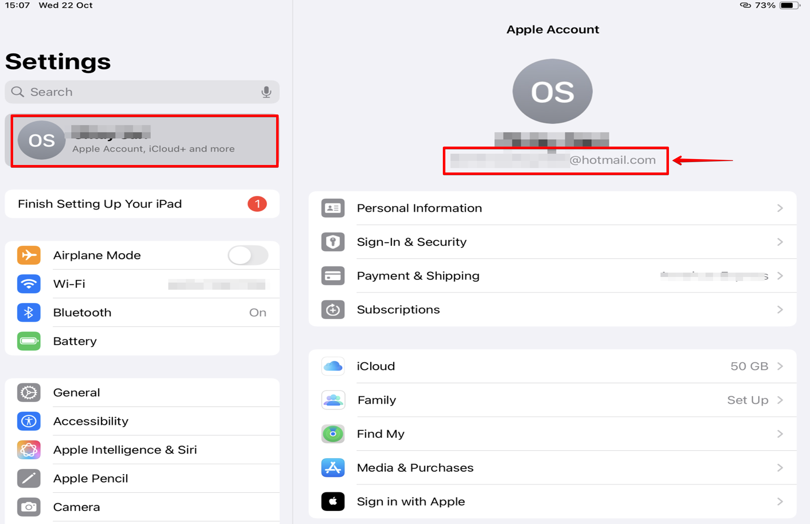

Frequently Asked Questions
What happens to my apps and purchases?
All apps you have purchased or downloaded remain available. Your purchases are linked to your Apple Account and will transfer to your new email address.
What happens to my iCloud data?
Your iCloud data (photos, contacts, notes, etc.) remains preserved and accessible through your updated Apple Account.
Do I need to sign in again to apps?
In some apps that use "Sign in with Apple," you may need to sign in again with your new email address.
What if I don't have a personal email address?
You can create a free email address at Gmail (google.com), Outlook (outlook.com), or another email provider.
Will I still have access to work apps?
Yes. Work apps and company resources are separate from your personal Apple Account. If your organization provides a managed Apple Account in the future, this will be a separate account.
What happens if I miss the 30-day deadline?
If you don't change your email address within 30 days, Apple will automatically assign a temporary email address to your account. You can then still sign in and change it to your preferred personal address, but this requires extra steps.

Need Help?
If you run into any issues or have questions, please contact the IT helpdesk.

